Virtual Memory Settings

David Graves
Colorado State University Global
CSC507
Dr. Joseph Issa
August 14, 2025

Virtual Memory
The use of Virtual Memory (VM) has been a critical memory management technique leveraged within computer operating systems to smooth physical memory constraints and optimize how physical storage is used, essentially increasing systems’ RAM capacity. This technique uses a portion of hard disk space as temporary storage and swaps ‘pages’ in and out to free up space when necessary. In practice, “virtual memory allows for very effective multiprogramming and relieves the user of the unnecessarily tight constraints of main memory.” (Stallings, n.d.) To better understand why and when one might want to use VM I’ll use the remainder of this paper to explore basic performance including program loading and functionality when I double the VM size and limit it to zero on my machine. Prior to performing this exercise, it’s helpful to get an understanding of how my machine is set up including OS, hardware, processor system type and RAM. This can help us understand what may be driving any underlying results found during the experiment. I found the following machine information displayed in Image 1 below. It looks like I have 32.0GB of RAM available and am running Windows 11 with an Intel Pentium Silver Processor all running in a Hewlett Packard body.
Image 1 (Machine Detail)
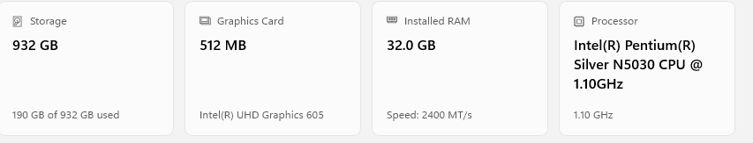
It also appears that Virtual Memory is set to automatically manage paging file size for all drives, which from what I’ve read is a decent option to run in Windows, “… resulting in better performance while preventing the system from freezing up if memory runs out.” (Huculak, 2024) As noted in Image 2 below the auto manage for Virtual Memory is set at minimum 16MB and recommended 4968MB available while currently 2048MB are allocated.
Image 2 (VM settings)
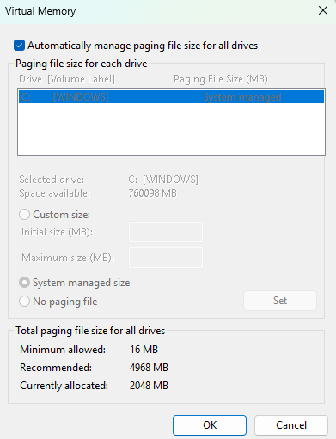
Tinkering with Virtual Memory
Now that I’ve got a good understanding of how my machine is set up, the next step was to get a good baseline understanding of how things run. To do this I rebooted my machine and loaded Ubuntu, Chrome, Outlook, Word, and Minecraft to see how well everything loaded and ran in conjunction. With that baseline established I navigated to the VM settings and doubled the allocation and performed the same test after rebooting. This didn’t seem to have much of an effect on performance with everything loading and running in about the same amount of time as before. The next question to answer was what happens to performance with VM turned off. For this, I navigated to the settings and turned off paging, rebooted and ran the same sequence of programs. This seemed like it slowed things down for all the programs to load, especially MineCraft. I’m guessing that’s because it probably uses more RAM to render and display the game. However, in total I don’t think that VM usage has a huge impact on my machine generally since most of the programs I run don’t come close to red lining the 32GB RAM and infrequently need to dip into Virtual Memory. Optimizing VM might be more necessary if I had 16GB or less.
Reflection
As shown by this basic experiment it’s helpful to have VM turned on and at least set to the automatic optimized setting for Windows for most of the daily use cases I have. Performance only dipped a hair when VM was turned off which makes sense as I don’t typically put too much stress on RAM. I don’t use this machine for too many programs where, “32GB or more may be better (like) for heavy gaming, editing videos in high resolution, and professional work that uses complicated software.” (Geekom, 2024) Looking forward, I want to keep an eye on memory management to ensure efficient settings as I continue to explore Deep Learning and Natural Language Processing as those applications typically rely on large datasets and complex modeling that can exhaust RAM quickly.

References
Geekom.co.uk (2024, Dec 25). Geekom.co.uk. Is 32GB RAM Overkill? The Ultimate Guide to
RAM for Your PC.
https://www.geekom.co.uk/is-32gb-ram-overkill#:~:text=Which%20one%20you%20choose%20(16GB,work%20that%20uses%20complicated%20software.
Huculak, Mauro (2024, July 17). Windowscentral.com. How to manage virtual memory on
Windows 11.
https://www.windowscentral.com/software-apps/windows-11/how-to-manage-virtual-memory-on-windows-11
Stallings, W. (n.d.). Operating Systems: Internals and Design Principles, 9/e.
Retrieved from: https://platform.virdocs.com/read/2228445/89/#/4/2[P7001013869000000000000000002EAA]/14[P700101386900000000000000000CBD3]/4[P700101386900000000000000000CBD6]/2[P700101386900000000000000000CBD7],/3:100,/3:100

